**Agent Management Platform (AMP) Research & Design**

**1. Introduction** The Agent Management Platform (AMP) is envisioned as a comprehensive, role-based solution to enable organizations to leverage AI for productivity gains, workflow automation, and knowledge worker assistance. This document compiles the research, competitive analysis, and design considerations that will guide the development of AMP.

**2. Core Vision & Objectives**

To empower organizations to effectively leverage AI for productivity gains, workflow automation, and knowledge worker assistance through a secure, intuitive, and powerful agent management platform.

* **Automate Workflows:** Enable end-to-end orchestration of business processes via AI-driven tasks and logic.
* **Enhance Productivity:** Provide pre-designed templates, generic prompts, and AI assistants to streamline repetitive work.
* **Assist Knowledge Workers:** Integrate a semantic knowledge base for rapid Q&A, document summarization, and contextual insights.
* **Empower Agent Creation:** Allow organizations to define, build, and deploy AI agents based on internal policies, procedures, and integrations.

**3. Key Functional Modules**

**3.1 AI Applications**

* **Workflow Automation:** Modular task orchestration with error handling, retries, and conditional logic. Streamline repetitive business processes and tasks.
* **Productivity Tools:** Library of workflow templates, prompt catalog, and AI-powered helpers. Offer pre-designed prompts and workflow templates for common tasks (e.g., content generation, data analysis, email marketing). Integrate AI assistance directly into user workflows.
* **Knowledge Worker Assistance:** Search, summarize, and interact with internal documents using Retrieval-Augmented Generation (RAG).
  + Establish a role-based knowledge base where users can upload, manage, and query information.
  + Implement data residency and retention policies to ensure compliance.
  + Provide AI-powered search and data-driven insights from the knowledge base.

**3.2 User Experience Layers**

**Hybrid UI Approach:** Combine a conversational chat interface (like ChatGPT) with a visual workflow builder (like Make.com or n8n) and embedded browser agents to cater to diverse user needs.

**Dual-Audience Focus:** Provide both no-code/low-code interfaces for business users and robust SDKs (like LangChain) for technical developers.

**Target User Personas**

* **Non-Technical Users (Business Users):**
  + **Goal:** To automate simple tasks and access information without writing code.
  + **Needs:** Guided tutorials, tooltips, workflow templates, and a simple, intuitive interface.
* **Technical Users (Developers, IT Professionals):**
  + **Goal:** To build complex, custom workflows and integrate the platform with other systems.
  + **Needs:** A robust interface, access to APIs, SDKs, and advanced configuration options.
* **Non-Technical UI:**
  + Guided workflow execution interface
  + Role-based pre-built workflows
  + Interactive tutorials, tooltips, and contextual help
* **Technical UI:**
  + Drag-and-drop workflow canvas
  + Create custom tools and prompts
  + JSON/YAML editor for advanced customization
  + Live debugging, logs, and version control

**UI Components**

* **Intuitive UI (for Non-Technical Users):**
  + A guided, template-driven experience.
  + Simplified workflow builder with clear instructions.
  + Dashboards focused on performance and results.
  + Examples from research: Gumloop's guided tutorials, Botpress's simple bot creation wizard.
* **Advanced UI (for Technical Users):**
  + A powerful, feature-rich interface for creating complex logic.
  + Access to code editors, API configuration panels, and detailed logs.
  + Version control and collaboration features.
  + Examples from research: n8n's node-based editor, Flowise's visual LangChain builder.

**3.3 Workflow Builder**

* Inspired by Make.com, n8n, gumloop and stack-ai
* **Extensible Ecosystem:** Develop a marketplace for pre-built agents, workflow templates, and third-party plugins, emulating the successful models of Google Cloud.
* **Vertical Specialization:** Create pre-configured agent templates for specific industries and departments like IT, HR, Marketing, and Sales.
* **Drag-and-Drop Interface:** An intuitive, visual canvas for creating and managing AI-driven workflows.
* **Pre-built Component Library:** A collection of modules for:
* **Data Processing:** Connectors for databases, APIs, and file storage.
* **AI Model Integration:** Seamlessly integrate with services like Azure OpenAI and Vertex AI.
* **Logic & Control Flow:** Conditional statements, loops, and branching.
* **Output Generation:** Modules for creating reports, sending notifications, and updating records.
* **System & API Integration:** Enable users to easily connect to and orchestrate actions across various internal and external systems.
* Canvas with:
  + AI service connectors (Azure OpenAI, Vertex AI)
  + Data ingestion/transformation components
  + Control structures: triggers, loops, conditions
  + SDK for custom components and integrations
* Versioning, rollback, and collaboration features

**3.4 Knowledge Base**

* Role-based data residency with configurable expiry
* Document ingestion (multimodal: text, files, images)
* Indexed with vector embeddings for RAG
* Internal Q&A system and semantic search interface

**3.5 AI Agent Studio**

* Agent templates (e.g., IT helpdesk, HR assistant, compliance monitor)
* Prompt library and task chaining
* Natural language → agent creation
* Integration with internal systems and APIs

**3.6 AI Agent Creation & Management**

* **Agent Definition:** Allow users to create AI agents based on organizational policies, procedures, and available integrations.
* **Knowledge Grounding:** Link agents to specific sections of the role-based knowledge base to ensure accurate and context-aware responses.
* **Tool Usage:** Equip agents with the ability to use internal and external tools and APIs to perform actions.
* **Governance & Oversight:** Implement built-in analytics and governance dashboards to monitor agent performance, usage, and compliance.

**4. Technical Architecture & Infrastructure**

**4.1. Core Infrastructure (Based on Research)**

* **Cloud Foundation:** Leverage a private GCP tenant for security and scalability.

Cloud Environment

* GCP Private Tenant: Ensures data residency, security, and compliance
* Services: Cloud Run, Cloud Functions, Cloud Storage, Cloud Build, Secret Manager
* VPC with subnet & firewall configurations
* **AI Service Integration:** Build connectors for existing Azure OpenAI and Vertex AI services.
* **Data Residency & Compliance:** Implement strict data residency controls using region-specific cloud storage and databases.

**4.2. Security & Compliance**

* **Role-Based Access Control (RBAC):** Ensure users can only access data and features relevant to their role.
* **Data Encryption:** Implement encryption at rest and in transit for all data.
* **Audit Logs:** Maintain comprehensive logs of all user and system activity for compliance and security analysis.

**4.3. Scalability & Performance**

* **Microservices Architecture:** Design the platform as a set of independent services for scalability and maintainability.
* **Load Balancing & Auto-scaling:** Ensure the platform can handle fluctuating user loads.
* **Performance Monitoring:** Implement tools to track and optimize platform performance in real-time.

**4.4. Analytics & Monitoring**

* Workflow execution metrics (latency, success rates)
* Agent usage statistics and adoption trends
* Model performance tracking (accuracy, cost)
* Alerting for failures, anomalies, and SLA breaches

**4.5. DevOps, Testing & QA**

* **CI/CD Pipelines:** Automated testing, linting, deployments via Cloud Build
* **Sandbox Environment:** Safe testing of workflows and agents
* **Automated Testing:** Unit, integration, and simulation-based agent tests

**5. Training, Documentation & Support**

* Comprehensive user guides for both personas
* Video tutorials and interactive walkthroughs
* Contextual tooltips and in-app help center
* Support ticketing and community forum

**6. Competitive Landscape & Inspiration**

|  |  |
| --- | --- |
| **Source** | **Key Feature & Takeaway** |
| ChatGPT (OpenAI) | Conversational UI, custom prompts, GPT marketplace |
| Make.com / n8n | Visual workflow builders, modular nodes, self-host options |
| MaxAI / Monica | Browser integration, model aggregation, context awareness |
| LangChain / LlamaIndex/ ADK | Agent memory, chaining, RAG framework |
| Perplexity | Sourced answers, follow-up Q&A |
| Relay.app | Personalization, multi-agent orchestration |
| Hugging Face | Model hub, community contributions, Spaces demos |

**Usability & Learning Curve**

| **Platform** | **Learning Curve** | **Target Expertise Level** | **Design Rating** |
| --- | --- | --- | --- |
| Gumloop | Low-Medium | Non-technical to technical | ⭐⭐⭐⭐⭐ |
| Stack AI | Medium | Business users to developers | ⭐⭐⭐⭐ |
| Max AI | Very Low | General users | ⭐⭐⭐⭐⭐ |
| n8n | Medium-High | Technical users | ⭐⭐⭐ |
| Make | Low | Non-technical users | ⭐⭐⭐⭐⭐ |

Inspiration:

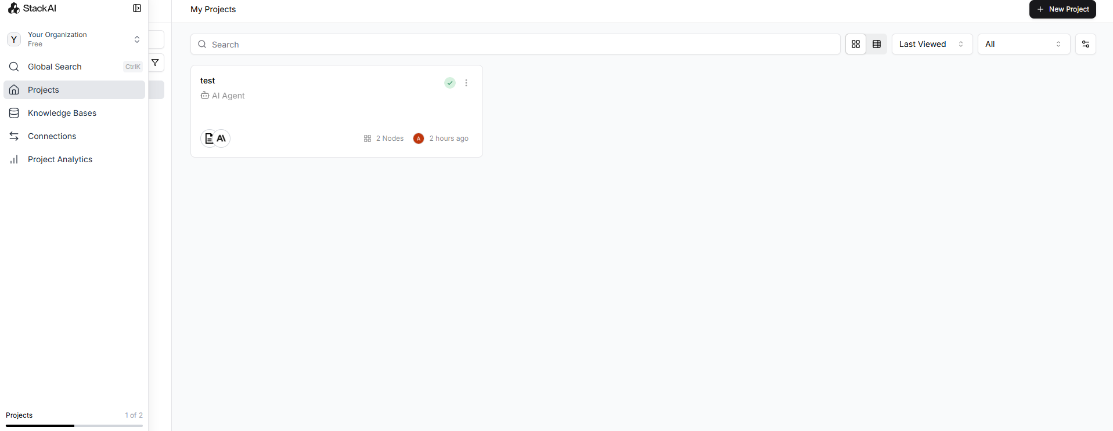

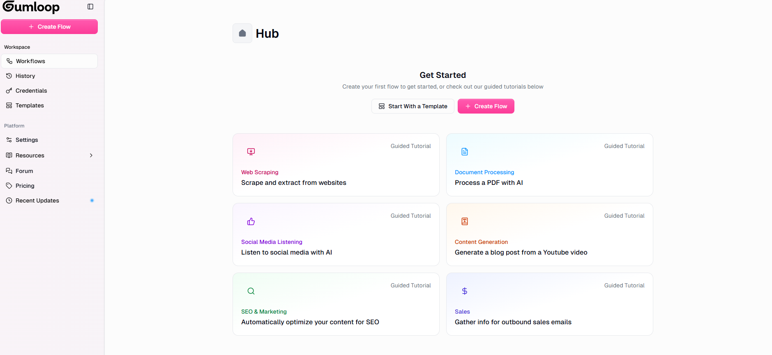

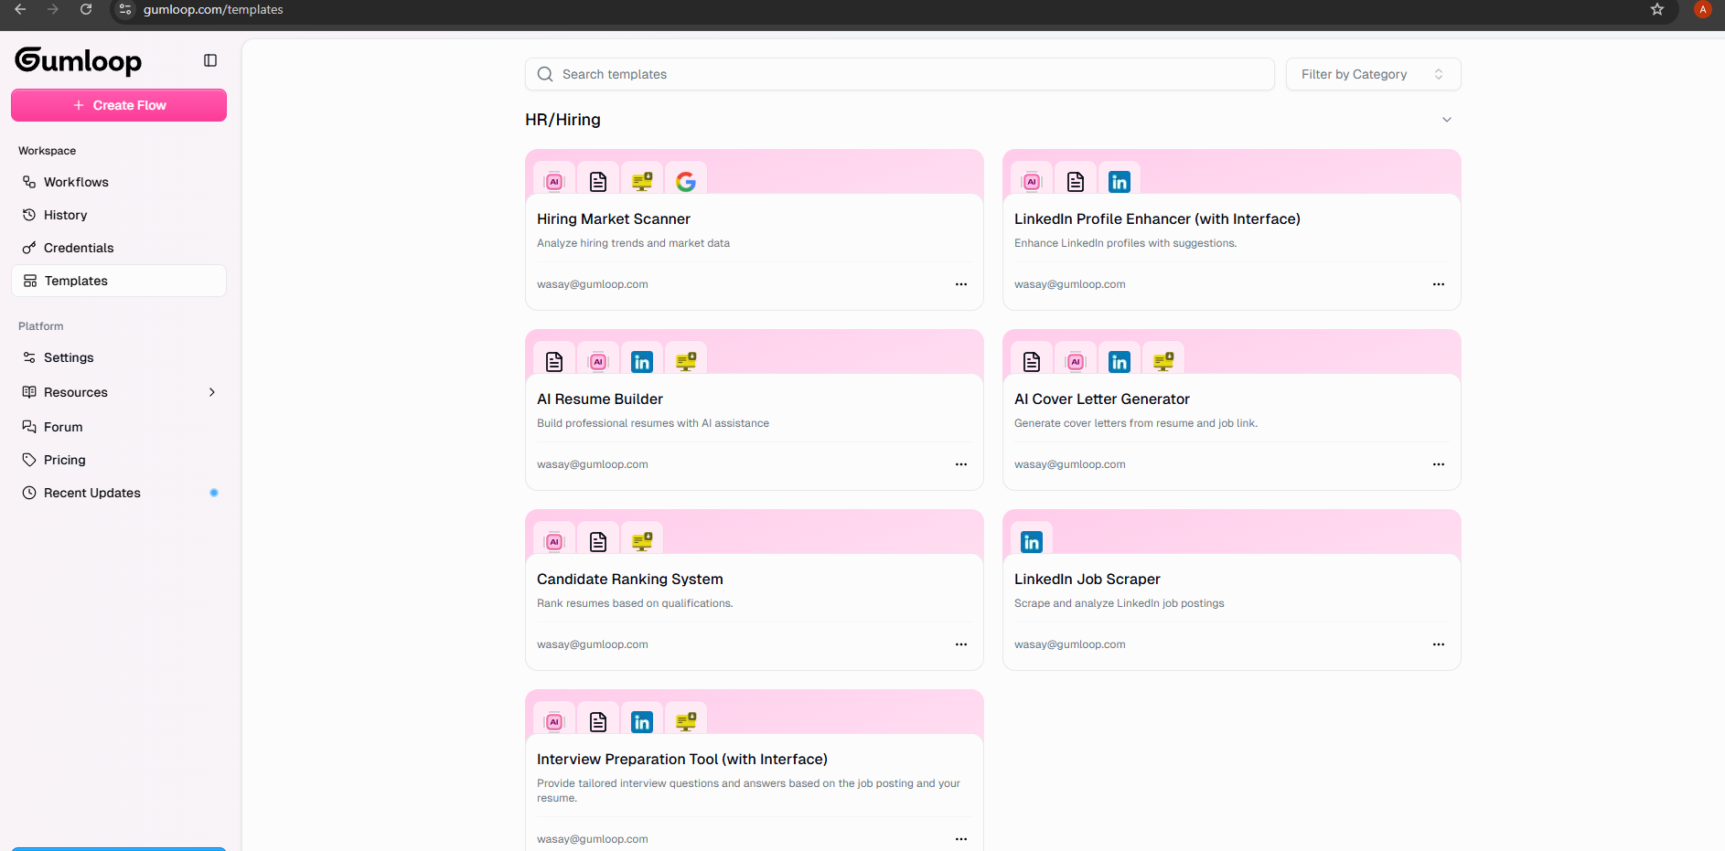

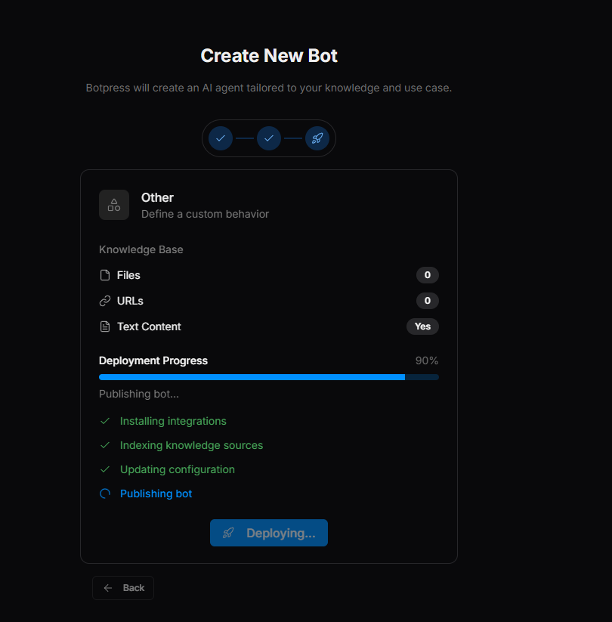

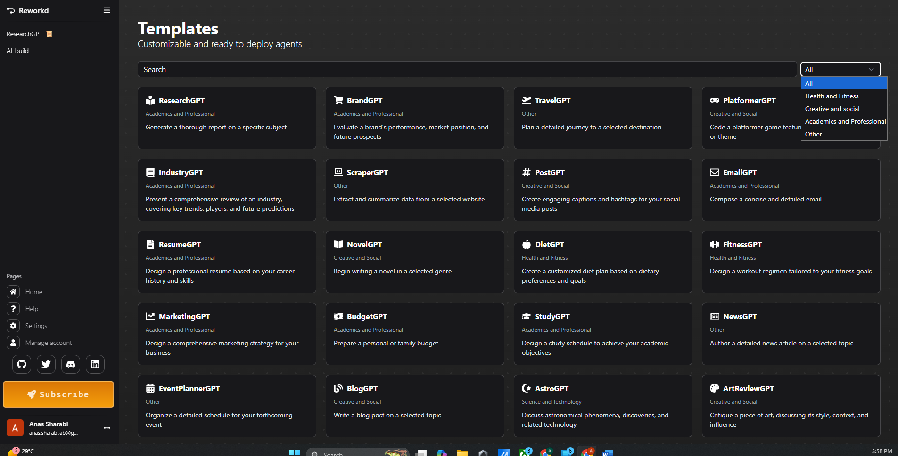

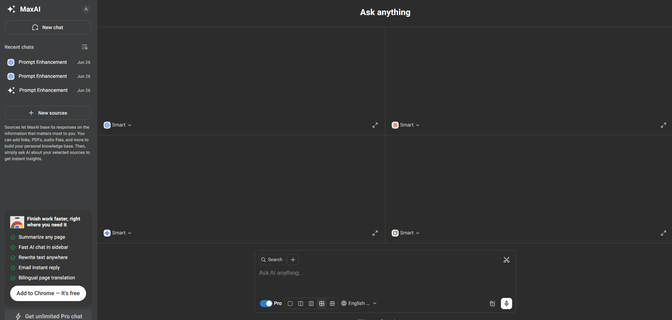

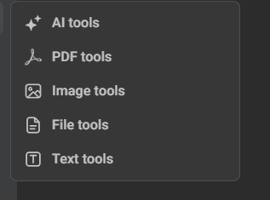

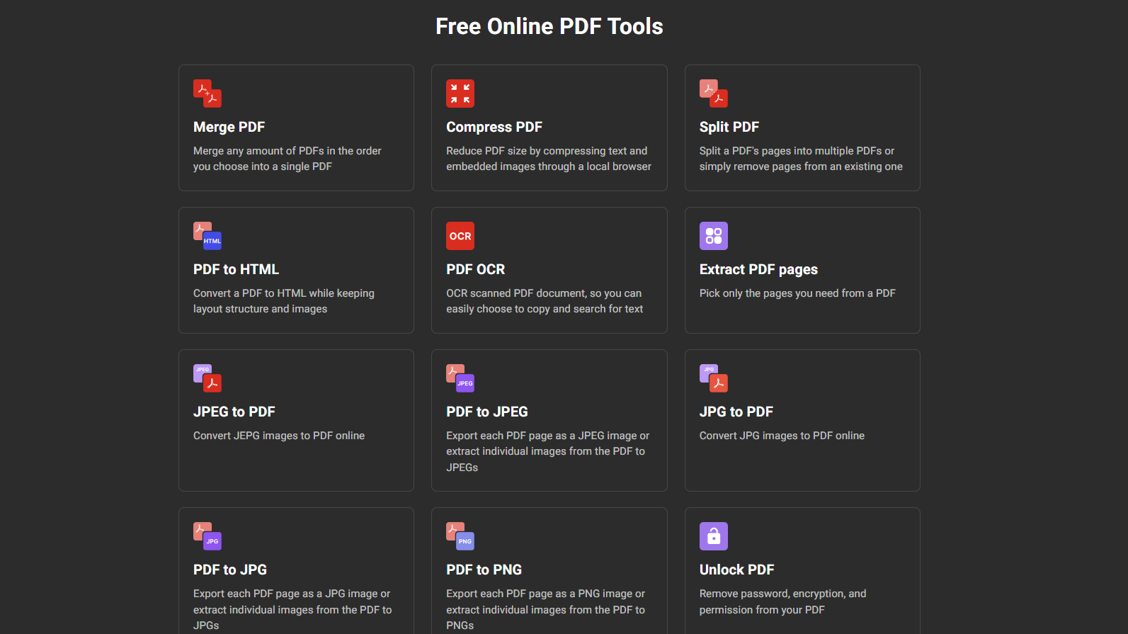

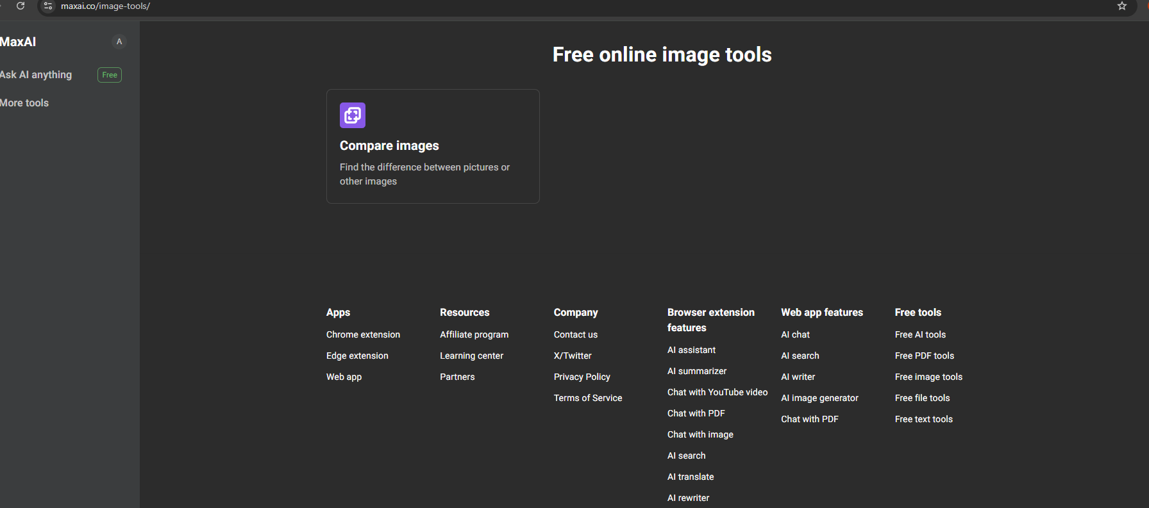

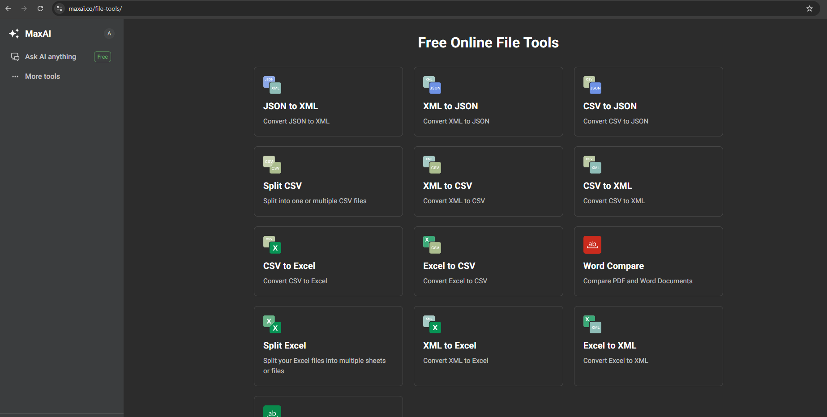

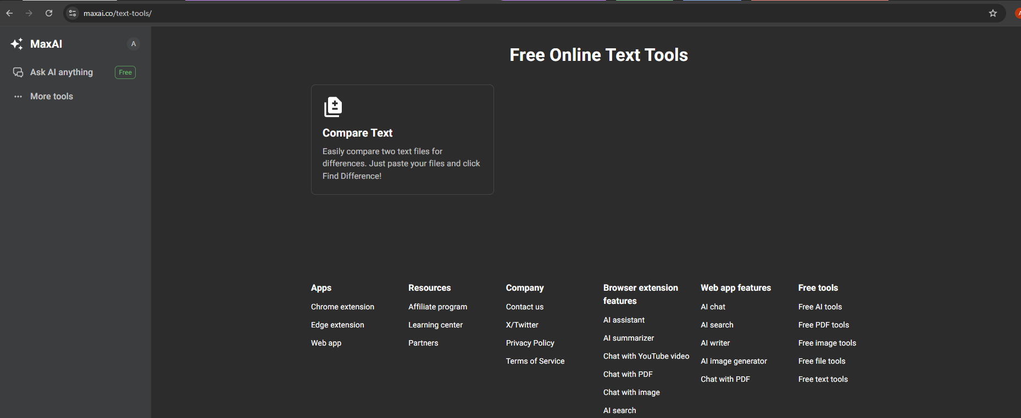

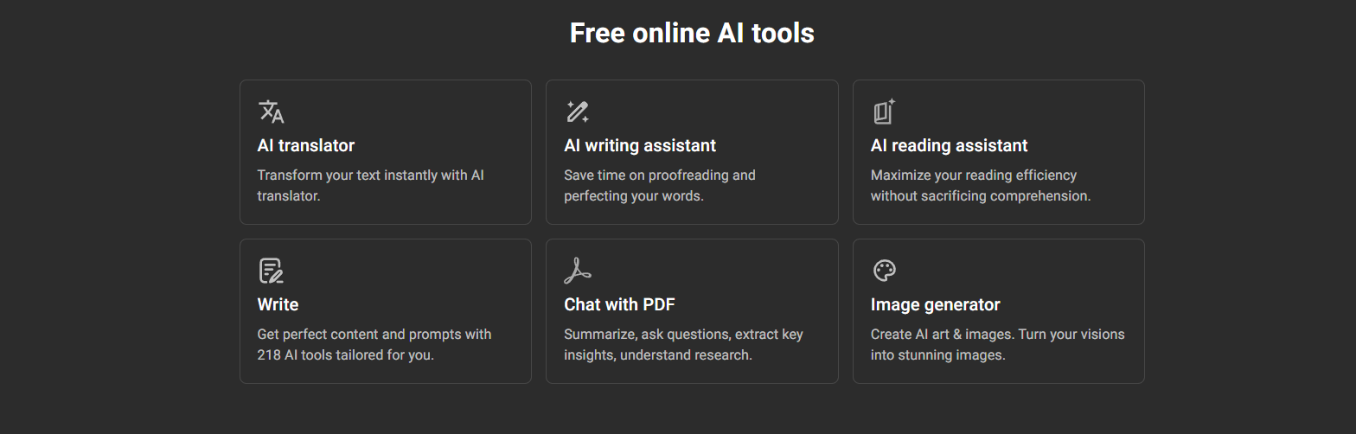

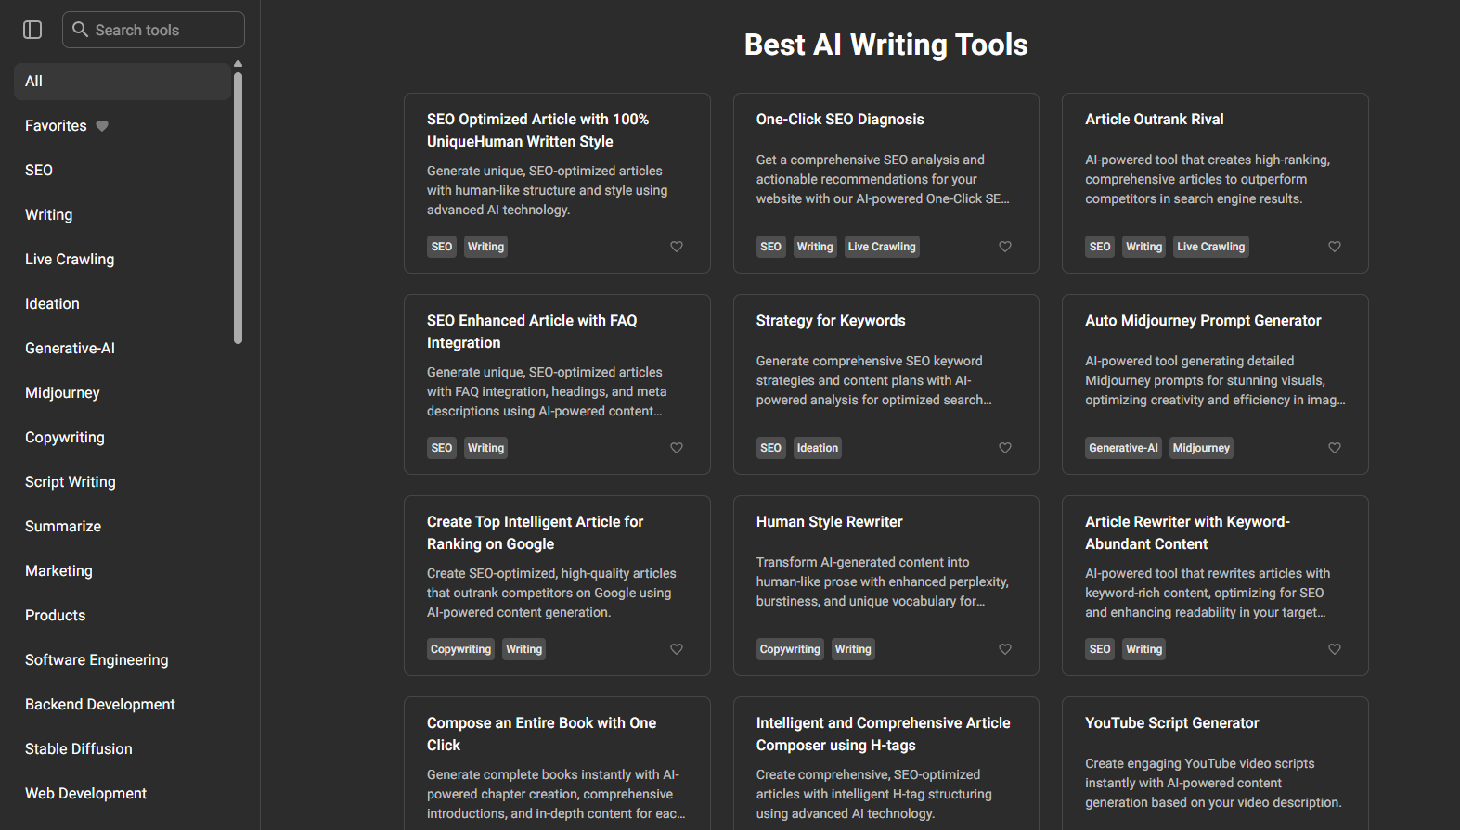

* AI Assistance
* AI Agents
* implementation Frameworks